JENKIN-DEPLOY

VPC:

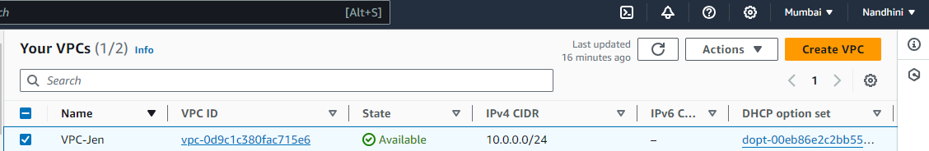

Subnets: 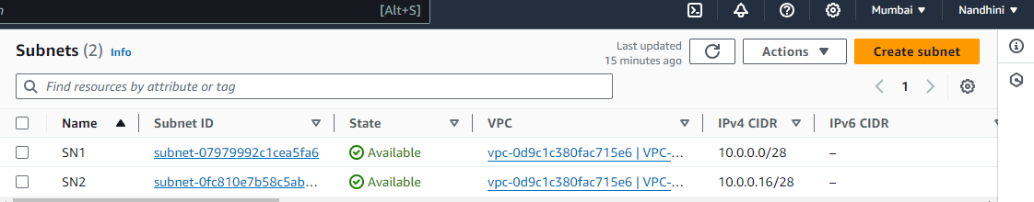

Route table:

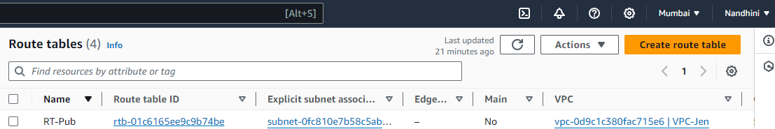

Instance:

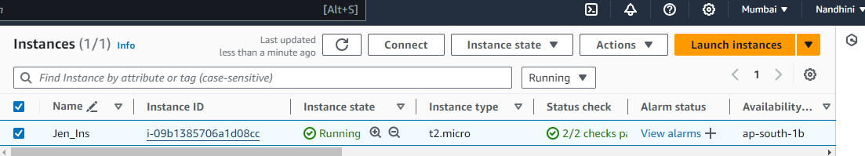

INITIAL IP: 3.109.55.77

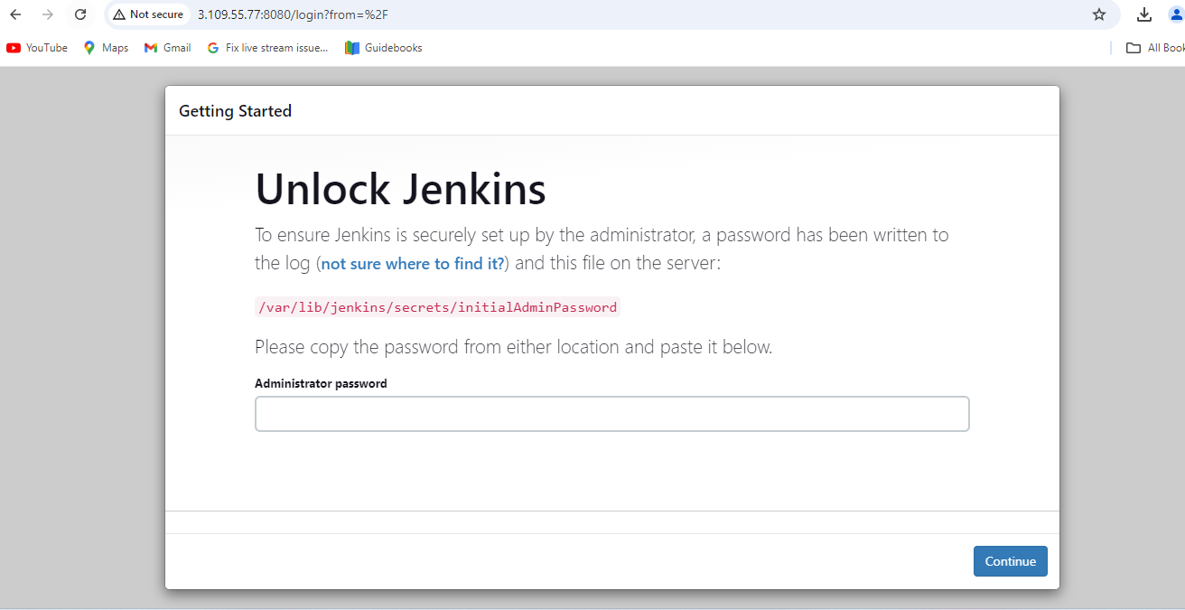

IP after stopped and started instance: 43.204.215.136

